No.7

Please submit this questionnaire by e-mail by Wed. July 10th, 2024

E-mail：　nia@nia.or.jp

You can also download this questionnaire from “Latest Information” list of Nagasaki International Association website.

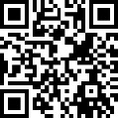

NIA website　<https://www.nia.or.jp>

Questionnaire for Organizations Participating in the 26th Nagasaki International

【About You】

|  |  |
| --- | --- |
| Name of Organization |  |
| Your name |  |
| Phone |  |
| E-mail |  |

【Desks, chairs, panels needed】

1.　Indicate the number of desks, chairs and panels you are planning to use.

|  |  |  |  |
| --- | --- | --- | --- |
|  | Desk (max. 2)  Dimensions：45㎝×180㎝ | Chair (max. 6) | Panel (max. 2)  Dimensions (w X h)  91cm×182cm  90cm×172cm |
| Qty |  |  |  |

2.　 Are you planning to use power outlet at the booth?

□　Yes　※What for?

□　No

【Leaflets handing out to the festival guests】

Nagasaki Lanka Nakama, please skip to #5. You don't need to fill out #3 or #4.

For the next questions, please refer to the 2023 version of 25th Nagasaki International Festival leaflet.

3.　This year, would you like to change the name of your organization from the one you used in 2023?

　　　　　　□　Yes

　　　　　　　　　　　　　Please answer the below 4 and 5.

①

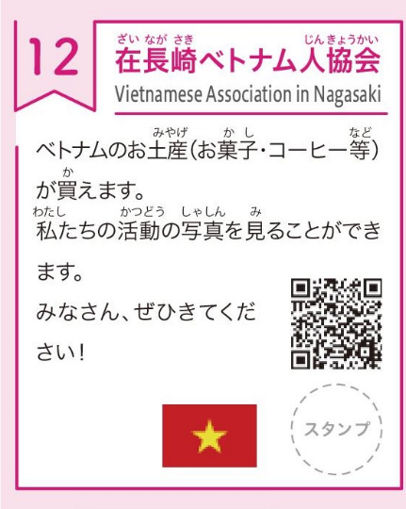□　No, same as 2023

　　　　　　　　　　　　　　　Go to Number 6



　　　　　　　　　　　　　　【Happy Present Quiz】



②



4.　If you answered “Yes” to Number 3, you’d like to change:

④



* ①　The name of your organization



* ②　Activities offered at the booth

③



* ③　National flag



* ④　QR code



5.　 If you chose ① in the question Number 4, please specify the new name

　　　　　　① Revised name of the organization

|  |  |
| --- | --- |
| Name (Upper side) |  |
| Name (Lower side) |  |

　　　　　　② Describe the activities offered at the festival　※In easy Japanese

|  |
| --- |
|  |

　　　　　　③　If you’d like to change the national flag, please send the jpeg file of the new flag in an e-mail with this questionnaire.

　　　　　　④　If you’d like to change the QR code, please send the jpeg file of the new flag in an e-mail with this questionnaire.

【Happy Present Quiz】

What is the “Happy Present Quiz”?

This quiz allows visitors to get to know about your organization.

How to conduct the quizzes

1. Each organization asks quiz participants a question about its organization.

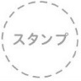

1. Stamp on the mark on the leaflet when a participant gives an answer.

※The stamp to be used will be lent by NIA.

1. Visitors will receive a prize if they collect 10 stamps.

6.　 Please create a quiz question about your organization for the “Happy Present Quiz”

※Please have the handouts with your quiz question and clues available at your booth.

※The quiz should be written in easy Japanese or in different languages for those who don’t understand Japanese.

　　　〈Example〉

　　　　A（Question）：　Who can foreigners living in Nagasaki call when they need help?

　　　　B（Please create three answer options for the quiz with one correct and two wrong answers.）：

①Fukuoka Consultation Center　　　　　②　Saga Consultation Center

③Nagasaki Consultation Center for Foreign People

　　　　C（Correct Answer）：　③

Question about your organization

|  |
| --- |
| A（Question）  B（Answer Options: 1 correct and 2 wrong answers）  C（Correct Answer） |

7.　Would you like us to translate your “Happy Present Quiz” question and answers in #6 into English?

　　　　□　Yes, please.

　　　　□　No, we will do the translation.

8．　Would you like for us to display photos of your organization’s activities on the large screen?

　　　　□　Yes, we’d like to show our photos.

Please choose up to 4 photos you would like to use in jpeg format and 　　e-mail them with this questionnaire.

　　　　□　No

【Parking on the Festival Day】

9．　Is your organization planning to park any vehicles at Nagasaki Prefectural Government Office parking lot on the day of the festival?

　　Each organization can park ONE vehicle in the Prefectural Government Office parking lot free of charge on the day of the festival.

* Yes, we are planning to park one vehicle.
* No, we don’t need a parking spot.

For any questions/Send this to:

Nagasaki International Association (NIA)

TEL: 095-823-3931　　E-mail:　nia@nia.or.jp PIC: Mrs. Araki